**Classification study guide Please turn in questions in red for homework. Submit as doc or docx.**

1. Circle the diagrams in which shaded portions depict clades.

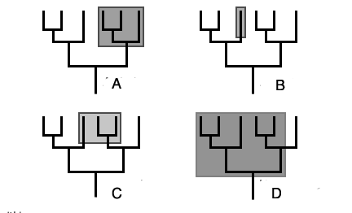

2. Distinguish between the terms, homologous and analogous.

3. Why is evolutionary systematics considered lacking in limits and hypothesis testing?

4. What is the difference between a shared derived homology (synapomorphy) and ancestral homology?

5. In the first tree depicting vertebrate relationships, which groups are included in the Amniotes?

6. Compare phylogenetics to traditional or evolutionary classification. Which scheme uses outgroups?